**Lab 2 [Making Ethernet cable using twisted-pair cables**

**(crisscross way)]**

**Objective**

● Create an ethernet cable using twisted pair cables in crisscross way

# Tools needed

* Unshielded Twisted pair cable (UTP)
* Modular connector (RJ45)
* Crimping tool
* LAN wire cutter
* Cable tester

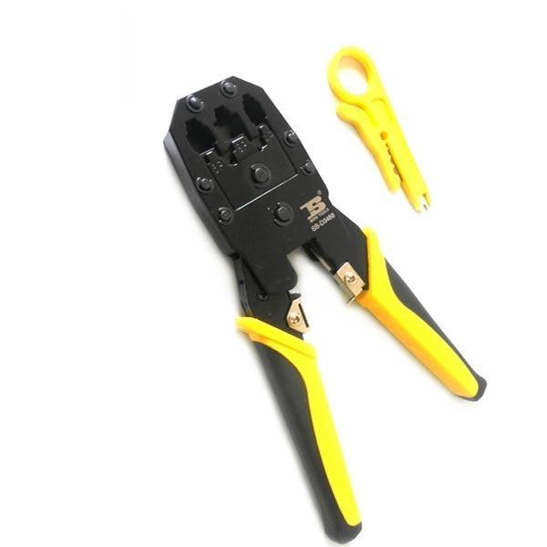

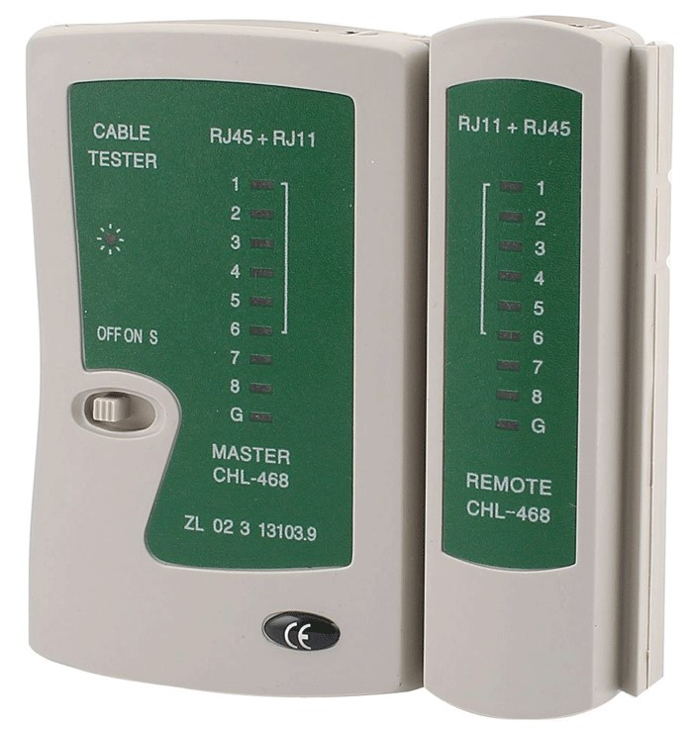

# Theory

* Ethernet cable is a widely used cabling technique in LAN networks that uses the Unshielded twisted pair cable as data transmitting wire and `RJ45` as a modular connector.
* It is relatively used to build within a few steps, and anyone can create it with the correct tools.
* It is cheap, easy to build, and highly reliable.
* In this lab, we used the standard color pin method to decide which colored wire goes in which pin in RJ45.

# Steps

1. Take a long set of the twisted pair cable wire.
2. Use a `LAN wire cutter` to cut the outer shell of the wire.
3. Use the `Crimping tool` to straighten the twisted wires.
4. Insert the wires in the standard format in `RJ45 connector`

For Side 1

|  |  |
| --- | --- |
| Pin | Wire Color |
| Pin 1 | Brown |
| Pin 2 | White/Brown |
| Pin 3 | Green |
| Pin 4 | White/Green |
| Pin 5 | White/Orange |
| Pin 6 | Blue |
| Pin 7 | White/Bkue |
| Pin 8 | Orange |

For Side 2

|  |  |
| --- | --- |
| Pin | Wire Color |
| Pin 1 | White/Green |
| Pin 2 | Green |
| Pin 3 | White/Orange |
| Pin 4 | Blue |
| Pin 5 | White/Blue |
| Pin 6 | Orange |
| Pin 7 | White/Brown |
| Pin 8 | Brown |

1. Use the `Crimping tool` to press RJ45 in place
2. Repeat steps 2, 3, 4, and 5 for the other side
3. Use `Cable tester` to check if all the wires are connected successfully and free of error.

